**Serial monitoring of LED Lights**

**Description**: In this project, we will control the led by using SERIAL MONITOR.

**Serial Monitor:**

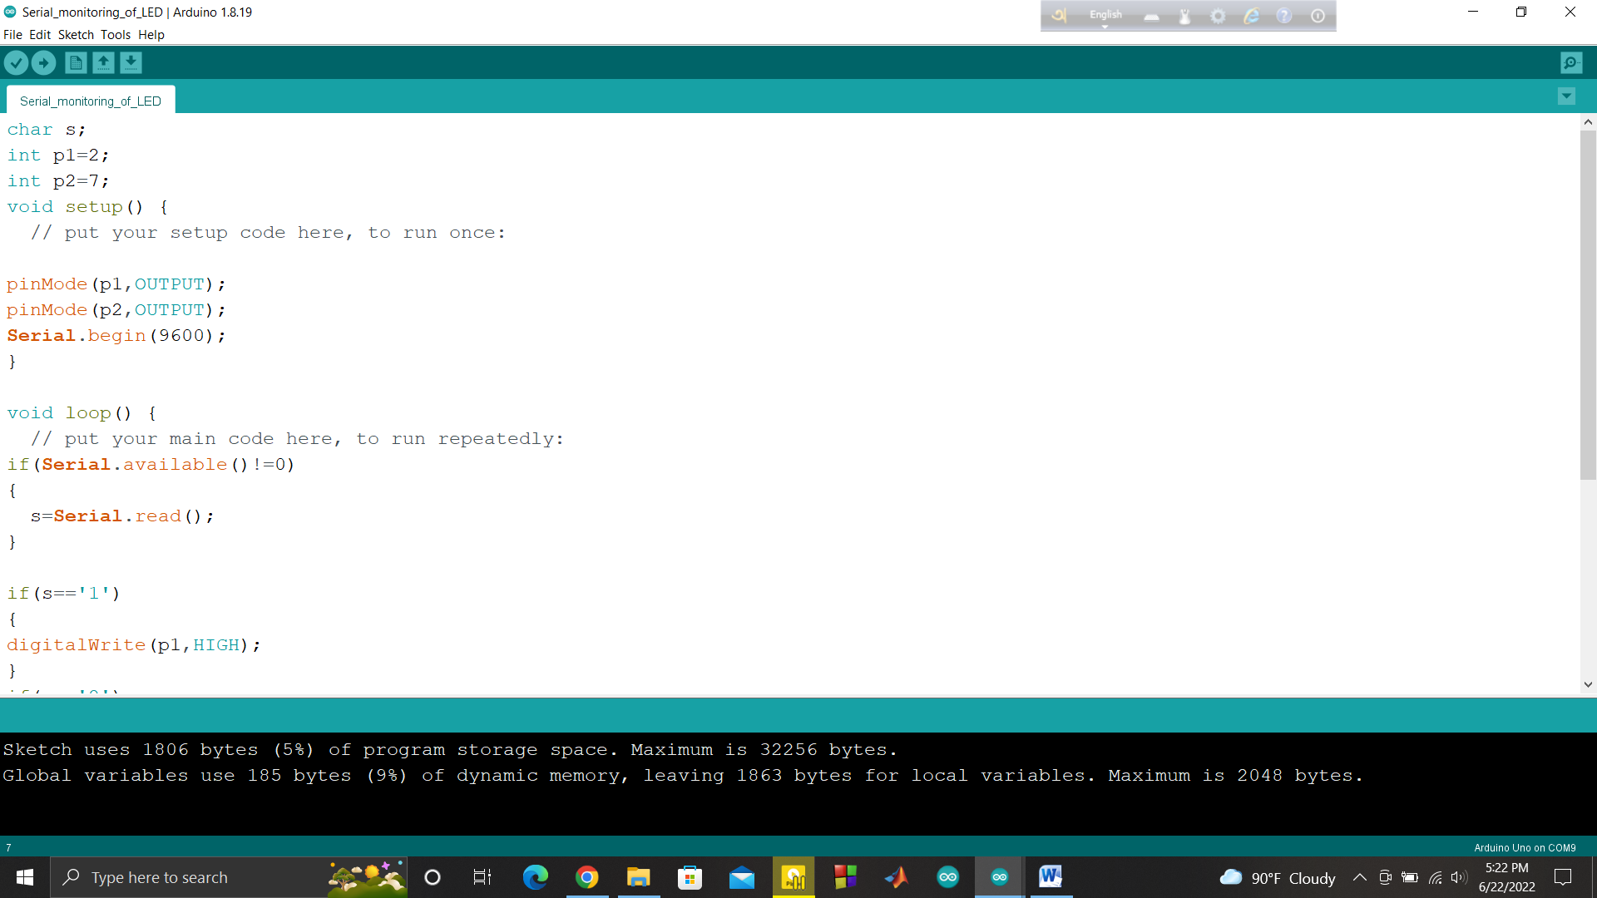

**After Clicking the pointer arrow:**

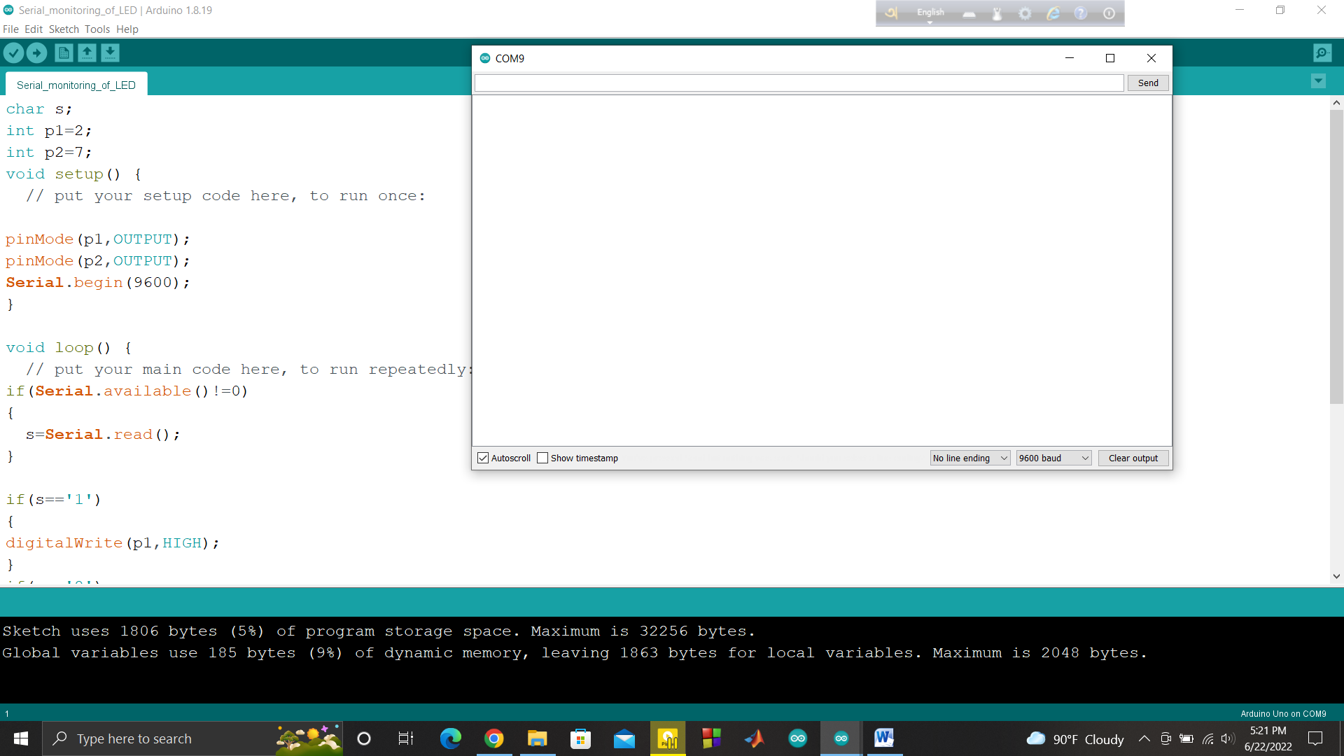

**This is Serial Monitor.**

**HardWare Requirement:**

* Arduino Uno board
* Jumper wire
* Breadboard
* 2 LED Lights

**Code:**

|  |
| --- |
| char s;  //state int p1=2; //pin1 int p2=7; //pin2 void setup() {   // put your setup code here, to run once:   pinMode(p1,OUTPUT); pinMode(p2,OUTPUT); Serial.begin(9600); }   void loop() {   // put your main code here, to run repeatedly: if(Serial.available()!=0) {   s=Serial.read(); }   if(s=='1') { digitalWrite(p1,HIGH);  } if(s=='2') { digitalWrite(p1,LOW);  } if(s=='3') { digitalWrite(p2,HIGH);  } if(s=='4') { digitalWrite(p2,LOW);  } } |

OUTPUT:

Step1: input 1 in the terminal

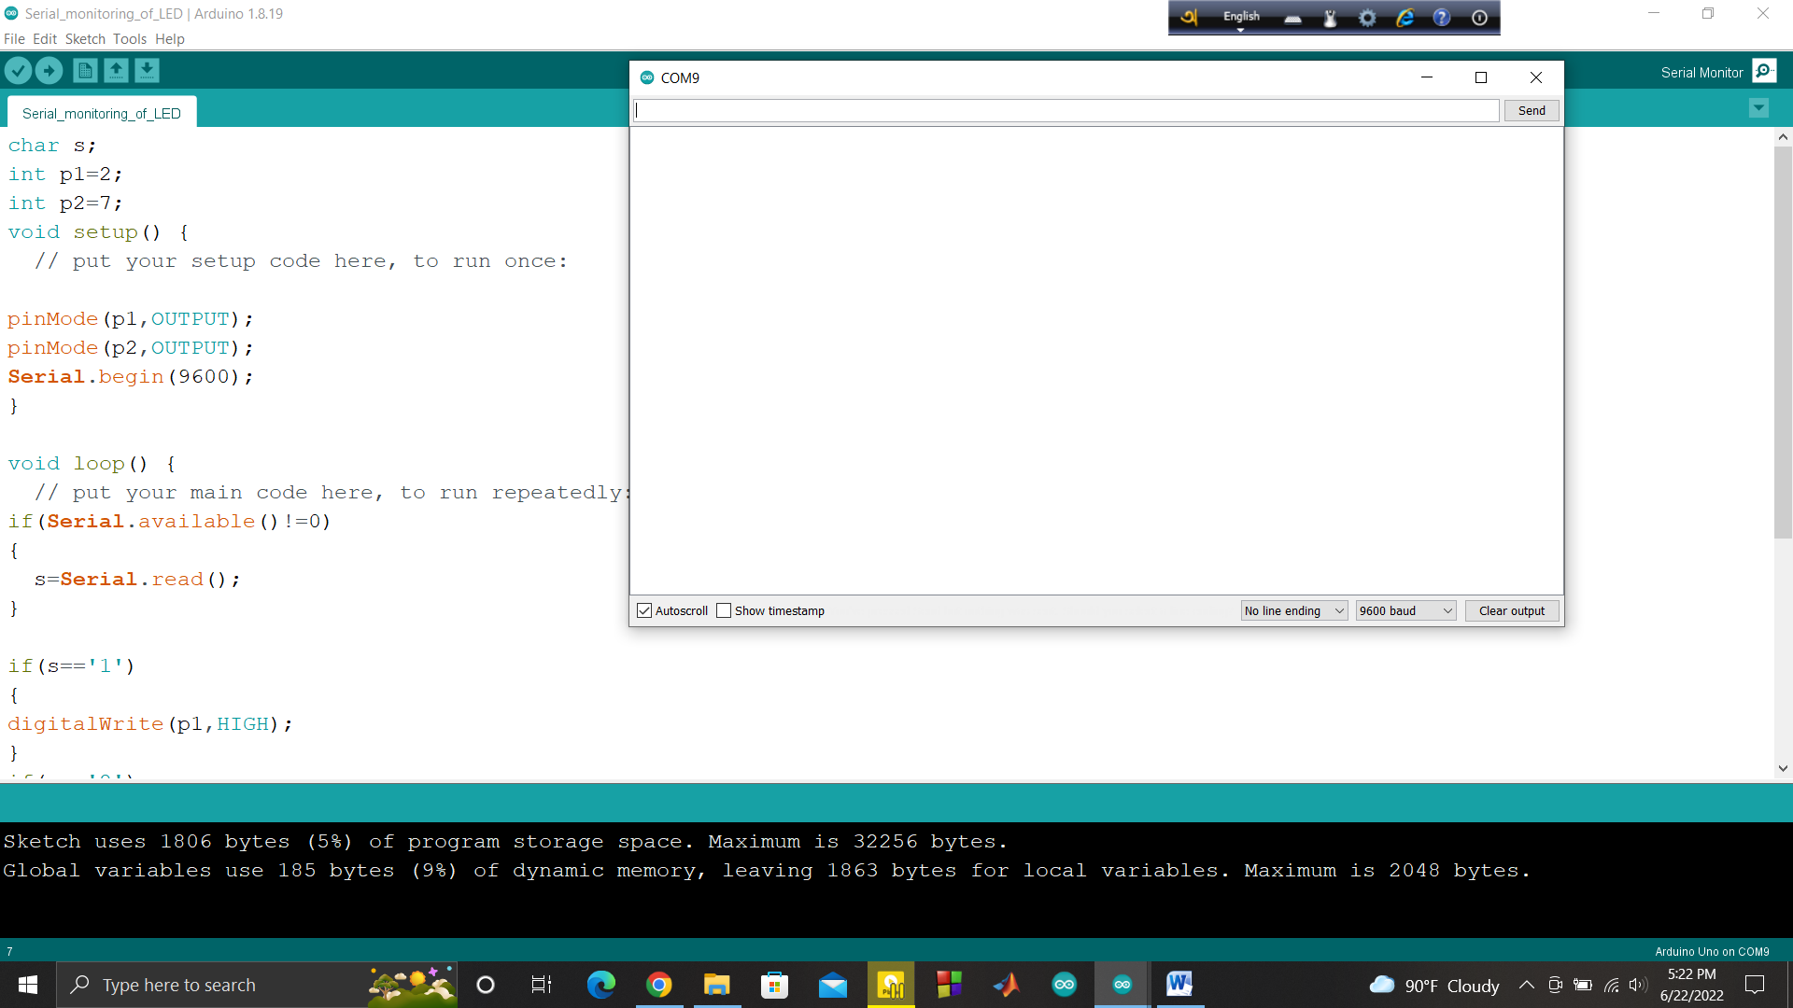

Then,

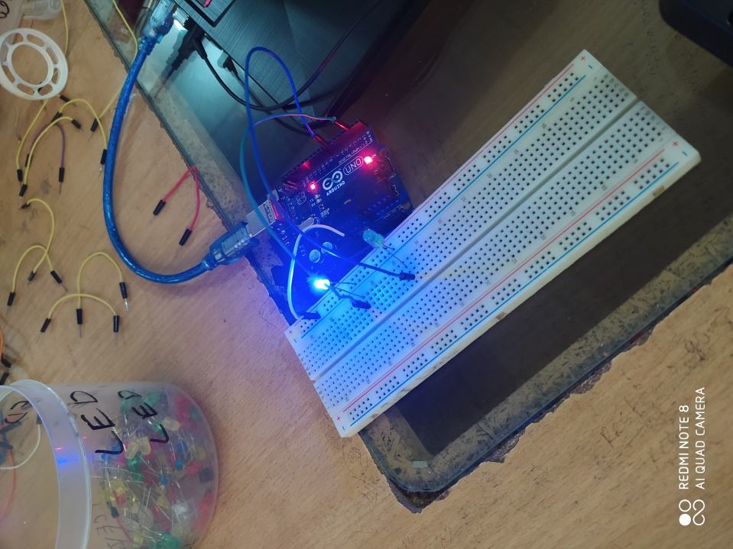

Step2: if inter 2 in the terminal



Then,

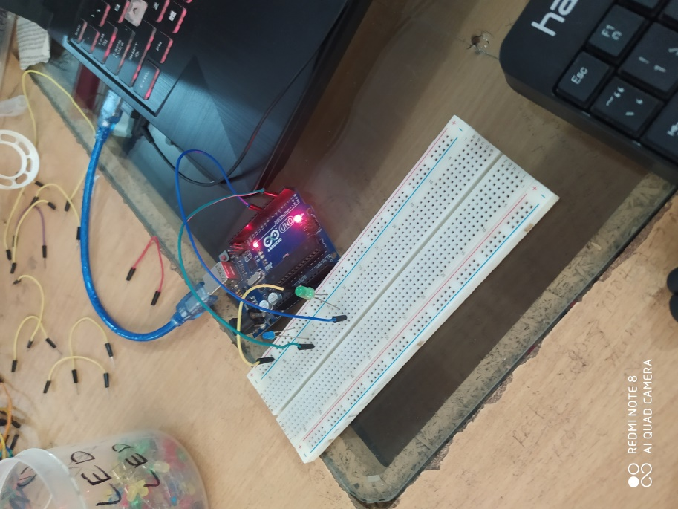

And you will do the same as well